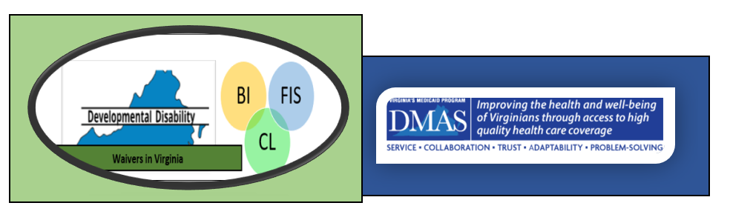
Services under the DD Waivers Overview

BI | FIS | CL | Residential Services
 |  |  | Independent Living Supports are provided to adults (18 and older) and offer skill building and support to secure a self-sustaining, independent living situation in the community and/or may provide the support necessary to maintain those skills.
 |  |  | In-Home Supports take place in the person’s and/or family’s home or community settings. Services are designed to ensure the health, safety and welfare of the person and expand daily living skills
 |  |  | Group Home Residential Services are provided in a DBHDS licensed home with staff available 24 hours per day to provide a skill building component, along with the provision of general health and safety supports, as needed.
 |  |  | Supported Living takes place in an apartment setting operated by a DBHDS licensed provider and provides 24/7 around the clock availability of staff support performed by paid staff who have the ability respond in a timely manner. May be provided individually or at the same time to more than one individual living in the home, depending on the required support.
 |  |  | Sponsored Residential take place in a DBHDS licensed family home where the homeowners are the paid caregivers (“sponsors”) who provide support as necessary so that the person can reside successfully in the home and community.
 |  |  | Shared Living is support to a person who resides in his/her own home/apartment in the community provided by a roommate of the person’s choosing. The individual receives a Medicaid reimbursement for the roommate’s portion of the total cost of rent, food, and utilities in exchange for the roommate providing minimal supports.

BI | FIS | CL | Crisis Services
 |  |  | Center-based Crisis Supports provide long-term crisis prevention and stabilization in a residential setting (Crisis Therapeutic Home) through planned and emergency admissions.
 |  |  | Community-Based Crisis Supports provided in the person’s home and community setting. Crisis staff work directly with and assist the person and his/her current support provider or family. These services provide temporary intensive supports to emergency psychiatric hospitalization, institutional placement or prevent other out-of-home placement.
 |  |  | Crisis support Services provide intensive supports to stabilize the person who may experience an episodic behavioral or psychiatric crisis in the community which has the potential to jeopardize his/her current community living situation.

BI | FIS | CL | Employment and Day Services
 |  |  | Individual Supported Employment is provided one-on-one by a job coach who offers training and support in a competitive job where persons without disabilities are employed.
 |  |  | Group Supported Employment is continuous employment-related support provided to a group of individuals working a competitive job where persons without disabilities are employed.
 |  |  | Workplace Assistance is provided to someone who requires more than typical job coach services to maintain individual, competitive employment.
 |  |  | Community Engagement provides a wide variety of opportunities to build relationships and natural supports in the community, while utilizing the community as a learning environment.
 |  |  | Community Coaching is designed for people who need one-to-one support in order build a specific skill or skills to address barrier(s) that prevents that person from participating in Community Engagement.
 |  |  | Group Day includes skill-building and support activities to gain or help keep social skills, self-help skills and other necessary skills to enhance independence and increase community integration. Can occur in a center and the community.

BI | FIS | CL | Additional Services
 |  |  | Assistive technology is specialized medical equipment, supplies, devices, controls, and appliances, not covered by insurance which enables persons to increase their independence in their environment and community.
 |  |  | Benefits Planning is a service that assists recipients of DD Waiver and social security to understand their personal benefits and explore their options regarding employment.
 |  |  | Community Guide Direct assistance (1:1) to persons in navigating and utilizing community resources. Provides information and assistance that help the person in problem solving, decision making, and developing supportive community relationships and other resources that promote implementation of the person-centered plan.
 |  |  | Electronic Home-Based Services are goods and services based on current technology to enable a person to safely live and participate in the community while decreasing the need for support staff services. This includes purchases of electronic devices, software, services, and supplies not otherwise provided through this waiver or through the State Plan, that would allow an individual to access greater independence and self-determination.
 |  |  | Individual and Family/Caregiver Training is training and counseling to individual, families and caregivers to improve supports or educate the person to gain a better understand of his/her abilities or increase his/her self-determination/self-advocacy abilities.
 |  |  | Environmental modifications are physical adaptations to the person's primary home or primary vehicle that are necessary to ensure the health and welfare of the person or enable the individual to function with greater independence.
 |  |  | Employment and Community Transportation promotes the individual’s independence and participation in the life of his or her community. Transportation to waiver and other community services or events, activities and resources, inclusive of transportation to employment or volunteer sites, homes of family or friends, civic organizations or social clubs, public meetings or other civic activities, and spiritual activities or events as specified by the service plan and when no other means of access is available.
 |  |  | Peer Mentor Supports is designed to foster connections and relationships which build individual resilience. This service is delivered by people with developmental disabilities who are or have received services, have shared experiences with the person, and provide support and guidance to him/her.
 |  |  | Transition services are nonrecurring set-up expenses for persons who are transitioning from an institution or provider-operated living arrangement to a living arrangement in a private residence where the person is directly responsible for his or her own living expenses.

tHE FOLLOWING THREE SERVICES ALLOW CONSUMER AND aGENCY dIRECTED mODELS
BI | FIS | CL
 |  |  | Personal Assistance Services includes monitoring health status, assisting with maintaining a clean and safe home and providing direct support with personal care needs at home, in the community, and at work.
 |  |  | Companion Services provide nonmedical care, socialization, or support to adults, ages 18 and older in a person’s home and/or in the community
 |  |  | Respite services are specifically designed to provide temporary, short-term care for a person when his/her unpaid, primary caregiver is unavailable

BI | FIS | CL | Medical and Behavior Services
 |  |  | Private Duty Nursing is individual and continuous care (in contrast to part-time or intermittent care) for people with a medical condition and/or complex health care need, to enable the person to remain at home.
 |  |  | Skilled Nursing is part-time or intermittent care provided by an LPN or RN to address or delegate needs that require the direct support or oversight of a licensed nurse. Nursing services can occur at the same time as other waiver services.
 |  |  | Therapeutic consultation is consultation with a professional designed to assist the individual’s staff and/or the individual’s family/caregiver, as appropriate, through assessments, development of TC supports plans, and teaching for the purpose of assisting the individual enrolled in the waiver with the designated specialty area. The specialty areas are psychology, behavioral consultation, therapeutic recreation, speech and language pathology, occupational therapy, physical therapy, and rehabilitation engineering
 |  |  | Personal Emergency Response System (PERS) is a service that monitors the individual’s safety in his/her home, and provides access to emergency assistance for medical or environmental emergencies through the provision of a two-way voice communication system that dials a 24-hour response or monitoring center upon activation and via the person’s home telephone system.

